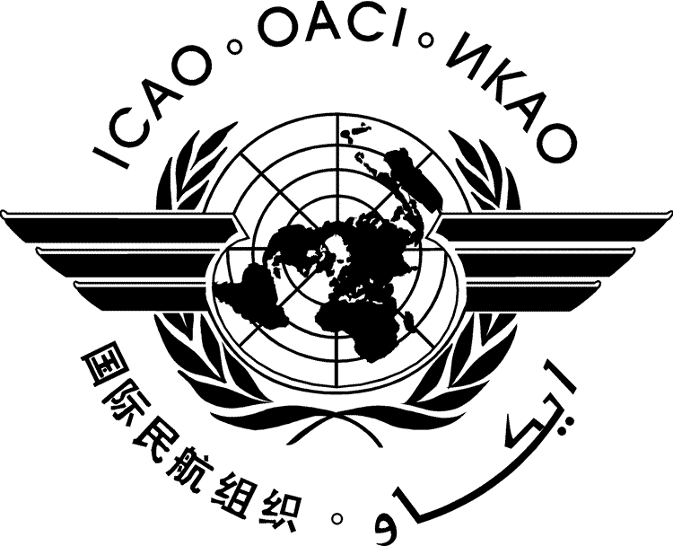 | International Civil Aviation Organization  WORKING PAPER | AN-Conf/12-WP/..  ../../12
TWELFTH AIR NAVIGATION CONFERENCE

Montréal, 19 to 30 November 2012

Agenda Item | x: | xx
 | x.x: | xx

TITLE

(Presented by xxx)

SUMMARY
This paper presents the …...

Action: The Conference is invited to …...

- INTRODUCTION
  - text
- BACKGROUND
  - text
- conclusion
  - text

— END —

